ATAR HUMAN BIOLOGICAL 12 SCIENCE

TEST 6

HOMINID EVOLUTION TRENDS

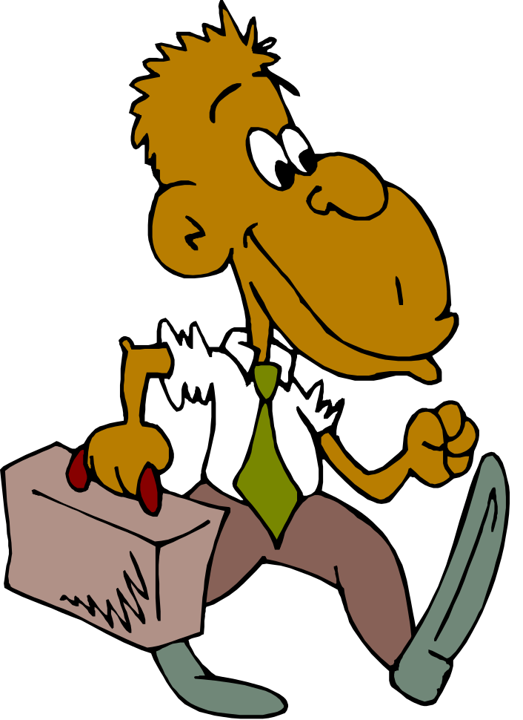

SECTION 1: MULTIPLE CHOICE 15 MARKS
SECTION 2: SHORT ANSWER 20 MARKS
SECTIION 3: EXTENDED ANSWER 10 MARKS

TOTAL TEST 45 MARKS
SECTION 1: MULTIPLE CHOICE: (15 marks):

1. The closest living relative of modern humans is

- chimpanzee
- Homo habilis
- Neanderthal
- Australopithecus

2. The part of the brain which is greatly increased in the more advanced primates is the

- cerebral cortex
- olfactory lobe
- cerebellum
- optic lobe

3. An evolutionary trend in the primates is that the relative importance of the sense of smell

a) has increased
b) remains constant
c) has reduced
d) varies with different species

4. The following is a list of characteristics possessed by humans.

- presence of hair on the body
- nails on digits
- forward facing eyes
- friction ridges on fingers
- development of young within the uterus

Which of these characteristics classifies man as a primate?

- I, IV and V
- II, III and V
- II and III only
- II, III and IV

5. Examine the following diagrams of primate feet.
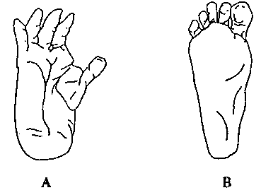
Which one of these statements about feet A and B is true?
  - A would be capable of prehensibility but not capable of opposability.
  - B would have a longitudinal arch suited to bipedalism whereas A would have a transverse arch suited to quadrupedalism.
  - B is best adapted to bipedalism because opposability and prehensibility are restricted
  - A shows adaptations suited to brachiation whereas B would be suited to quadrupedalism.

6. The opening beneath the cranium through which the spinal cord passes is known as the

- foramen ovale
- foramen cervix
- foramen magnum
- foramen major

7. Stereoscopic vision is best described as:

- the ability to see near and far objects
- the ability to see with both eyes at the same time
- eyes which can see both straight ahead and around to 120 degrees to the sides
- eyes with overlapping fields of vision

8. Pentadactyl refers to an animal possessing:

  - a tail that can be used as an extra limb
  - a ridge of bone on the top of the skull
  - a hand with five digits
  - the ability of the thumb to touch all fingers

9. The tool shown in the diagram below is typical of which human ancestor?

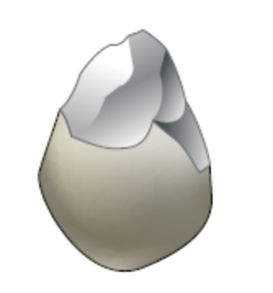

  - Neanderthal
  - Homo erectus
  - Australopithecus
  - Gorilla

- Consider the following diagrams of Hominin skulls.

The correct sequence of evolution, from oldest to youngest, of the Hominin species shown is
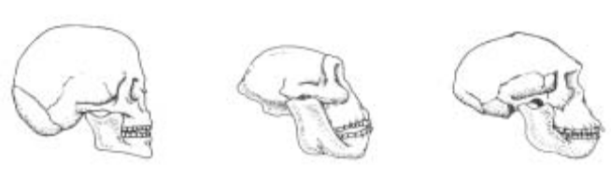

1 2 3

a) 2, 3, 1
b) 3, 1, 2
c) 1, 2, 3
d) 2, 1, 3

11. In man, the fact that the index finger and the thumb are fully opposable enables him to

a) use the power grip
b) brachiate successfully
c) use the precision grip
d) use bipedal locomotion

12. Which of the following primates would you expect to have the most highly developed cerebral cortex area of the brain?

- Siamang (lesser ape)
- Squirrel monkey (New World Monkey)
- Tarsier
- Macaque (Old World Monkey)

13. Natural selection has resulted in a decrease in the number of teeth in primates when compared to other mammals and also as one moves from more primitive to more advanced primates. This is probably related to

a) a more advanced lifestyle
b) an increase in the size of the teeth
c) a reduction in the size and shape of the jaw
d) the development of larger canine teeth

14. The advantage of stereoscopic vision, is that it gives an animal:

a) the ability to see in colour
b) the ability to see in the dark
c) the ability to see better over long distances
d) the ability to judge distances

15. Human offspring are dependent on their parents for much longer than other primates. This gives them more time

a) to pass on ideas and skills
b) to mature physically
c) for the brain to increase in complexity
d) to grow taller

END OF SECTION 1

YEAR 12 ATAR HUMAN BIOLOGY STAGE 4
ASSESSMENT TASK 15: Human Evolution Test 6

NAME: ______________________________________________________________
TEACHER: __________________________________________________________

SECTION A: MULTIPLE CHOICE: (25 MARKS):

Place an X through the correct response:

1. [A] [B] [C] [D] 14. [A] [B] [C] [D]

2. [A] [B] [C] [D] 15. [A] [B] [C] [D]

3. [A] [B] [C] [D] 16. [A] [B] [C] [D]

4. [A] [B] [C] [D] 17. [A] [B] [C] [D]

5. [A] [B] [C] [D] 18. [A] [B] [C] [D]

6. [A] [B] [C] [D] 19. [A] [B] [C] [D]

7. [A] [B] [C] [D] 20. [A] [B] [C] [D]

8. [A] [B] [C] [D] 21. [A] [B] [C] [D]

9. [A] [B] [C] [D] 22. [A] [B] [C] [D]

10. [A] [B] [C] [D] 23. [A] [B] [C] [D]

11. [A] [B] [C] [D] 24. [A] [B] [C] [D]

12. [A] [B] [C] [D] 25. [A] [B] [C] [D]

13. [A] [B] [C] [D]

SECTION 2: SHORT ANSWER: (20 marks):

16. Define the following terms. (5 marks)

- Friction ridges
--------------------------------------------------------------------------------------------------------------------------------------------------------------------------------------------------------------------------------
- Diastema
--------------------------------------------------------------------------------------------------------------------------------------------------------------------------------------------------------------------------------

- Muscle tone
--------------------------------------------------------------------------------------------------------------------------------------------------------------------------------------------------------------------------------

- Prognathism
--------------------------------------------------------------------------------------------------------------------------------------------------------------------------------------------------------------------------------

- Gestation period
--------------------------------------------------------------------------------------------------------------------------------------------------------------------------------------------------------------------------------

17. List three advantages an organism gains from having an erect stance and bipedal locomotion. (3 marks)
------------------------------------------------------------------------------------------------------------------------------------------------------------------------------------------------------------------------------------------------------------------------------------------------------------------------------------------------------------------------------------------------------------------------------------------------------------------------------------------------------------------------------------------------------------------------------------------------------------------------------------------------------------------------------------------------------------------------------------------------------

18. There is a trend in brain size and complexity from the earliest examples of the genus Homo to modern day humans. Explain what this trend is and how it has contributed to the success of modern humans. (4 marks)
--------------------------------------------------------------------------------------------------------------------------------------------------------------------------------------------------------------------------------------------------------------------------------------------------------------------------------------------------------------------------------------------------------------------------------------------------------------------------------------------------------------------------------------------------------------------------------------------------------------------------------------------------------------------------------------------------------------------------------------------------------------------------------------------------------------------------------------------------------------------------------------------------------------------------------------------------------------------------------------------------------------------------------------------------------------------------------------------------------------------------------------------------------------------------------------------------------------------------------------------------------------------

19. “By the time of Homo erectus, the effect of the environment as a selective agent was diminishing. These hominins were now modifying their environment to suit their own purpose.”

Explain how hunting, the use of tools and the use of fire helped these hominins to survive. (6 marks)
---------------------------------------------------------------------------------------------------------------------------------------------------------------------------------------------------------------------------------------------------------------------------------------------------------------------------------------------------------------------------------------------------------------------------------------------------------------------------------------------------------------------------------------------------------------------------------------------------------------------------------------------------------------------------------------------------------------------------------------------------------------------------------------------------------------------------------------------------------------------------------------------------------------------------------------------------------------------------------------------------------------------------------------------------------------------------------------------------------------------------------------------------------------------------------------------------------------------------------------------------------------------------------------------------------------------------------------------------------------------------------------------------------------------------------------------------------------------------------------------------------------------------------------------------------------------------------------------------------------------------------------------------------------------------------------------------------------------------------------------------------------

20. Explain the significance of the Laetoli footsprints, which were thought to have been made around 3.5 million years ago. (2 marks)
--------------------------------------------------------------------------------------------------------------------------------------------------------------------------------------------------------------------------------------------------------------------------------------------------------------------------------------------------------------------------------------------------------------------------------------------------------------------------------------------------------

END OF SECTION 2

SECTION 3: EXTENDED ANSWER: (10 marks):

21. Being able to stand upright and walk bipedally has given humans advantages that have helped them to survive. Changes have occurred in the skull, vertebral column, pelvis, legs and feet. Describe how each of these has contributed to enable humans to adopt an erect stance. (10 marks)
--------------------------------------------------------------------------------------------------------------------------------------------------------------------------------------------------------------------------------------------------------------------------------------------------------------------------------------------------------------------------------------------------------------------------------------------------------------------------------------------------------------------------------------------------------------------------------------------------------------------------------------------------------------------------------------------------------------------------------------------------------------------------------------------------------------------------------------------------------------------------------------------------------------------------------------------------------------------------------------------------------------------------------------------------------------------------------------------------------------------------------------------------------------------------------------------------------------------------------------------------------------------------------------------------------------------------------------------------------------------------------------------------------------------------------------------------------------------------------------------------------------------------------------------------------------------------------------------------------------------------------------------------------------------------------------------------------------------------------------------------------------------------------------------------------------------------------------------------------------------------------------------------------------------------------------------------------------------------------------------------------------------------------------------------------------------------------------------------------------------------------------------------------------------------------------------------------------------------------------------------------------------------------------------------------------------------------------------------------------------------------------------------------------------------------------------------------------------------------------------------------------------------------------------------------------------------------------------------------------------------------------------------------------------------------------------------------------------------------------------------------------------------------------------------------------------------------------------------------------------------------------------------------------------------------------------------------------------------------------------------------------------------------------------------------------------------------------------------------------------------------------------------------------------------------------------------------------------------------------------------------------------------------------------------------------------------------------------------------------------------------------------------------------------------------------------------------------------------------------------------------------------------------------------------------------------------------------------------------------------------------------------------------------------------------------------------------------------------------------------------------------------------------------------------------------------------------------------------------------------------------------------------------------------------------------------------------------------------------------------------------------------------------------------------------------------------------------------------------------------------------------------------------------------------------------------------------------------------------------------------------------------------------------------------------------------------------------------------------------------------------------------------------------------------------------------------------------------------------------------------------------------------------------------------------------------------------------------------------------------------------------------------------------------------------------------------------------------------------------------------------------------------------------------------------------------------------------------------------------------------------------------------------------------------------------------------------------------------------------------------------------------------------------------------------------------------------------------------------------------------------------------------------------------------------------------------------------------------------------------------------------------------------------------------------------------------------------------------------------------------------------------------------------------------------------------------------------------------------------------------------------------------------------------

END OF TEST

